Practical 1 - MongoDB Basics:1
- Write a MongoDB query to create and drop database.
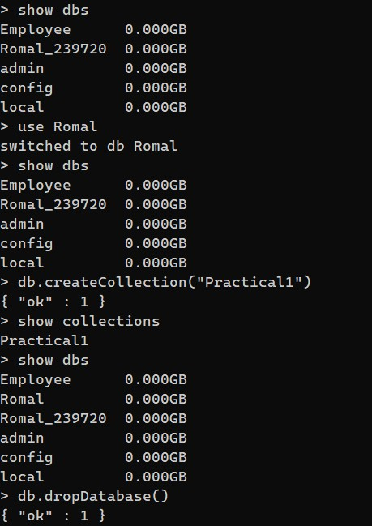

- Write a MongoDB query to create, display and drop collection.
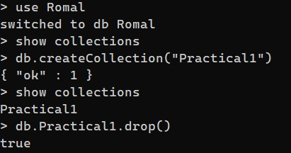
- Write a MongoDB query to insert, query, update and delete a document.
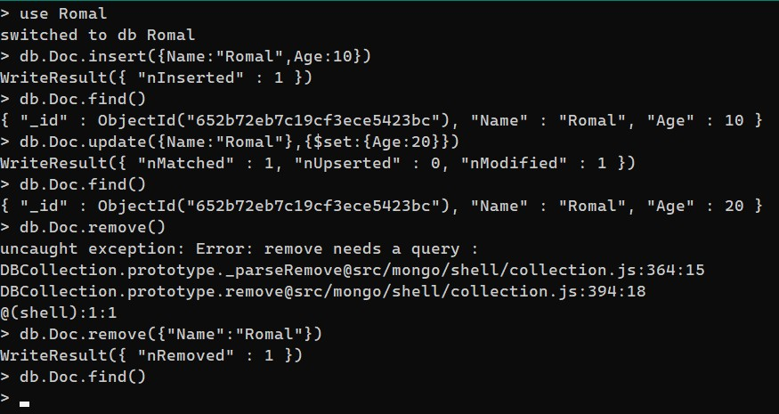

- Employee Queries
- Insert and display the documents in the Employee collection.
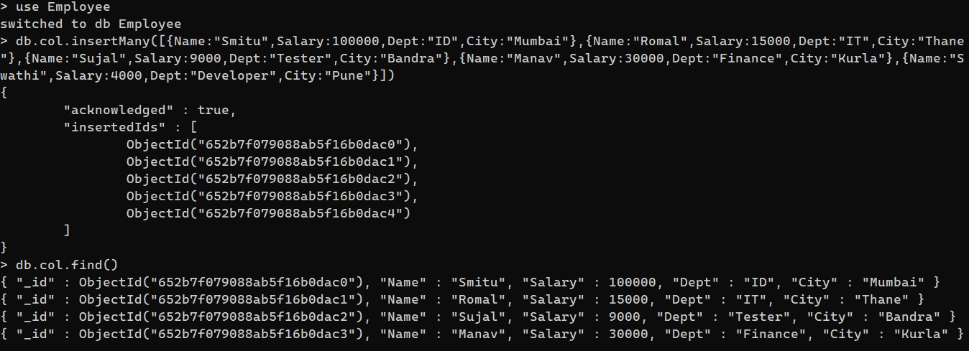

- Display details of employees who live in Mumbai.
- Display details of employee staying in Kurla and salary greater than 19000

- Display details of the employee whose salary is greater than equal 10000 but less than 20000.

- Display details of employees staying in either thane or mumbai and salary greater than 10000.

- Display details of employee whose salary is not equal to 10000 and working in either developer or tester department.

    - Practical 2 - MongoDB Basics:2
    - Insert the documents
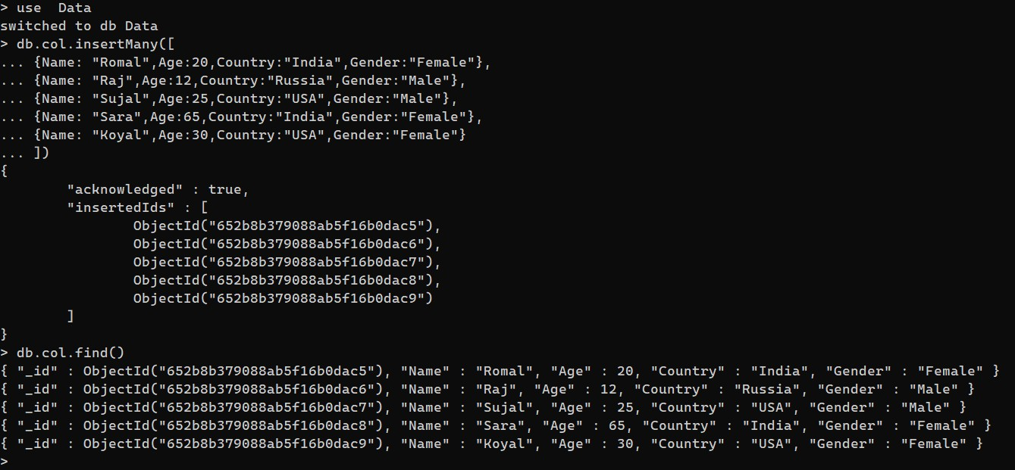

    - Update the country to UK for all female users.
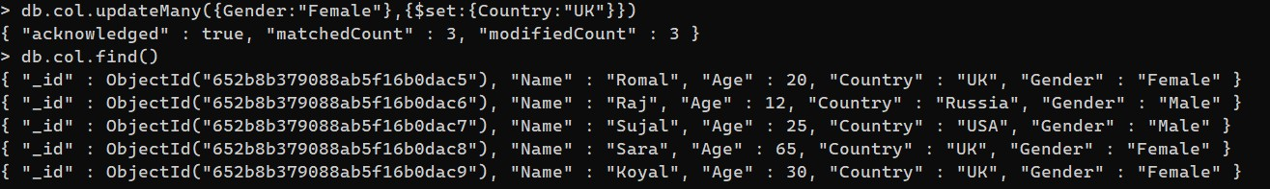

    - Add the new field company to all the documents.
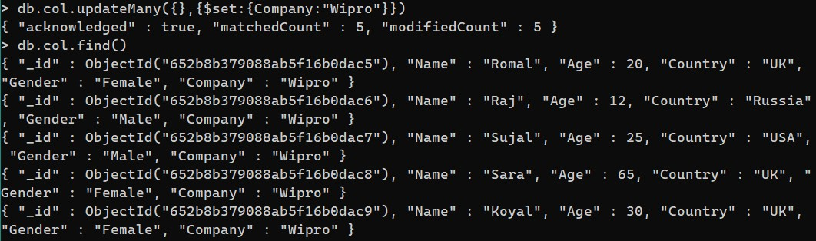

    - Delete all the documents where Gender = ‘M’.
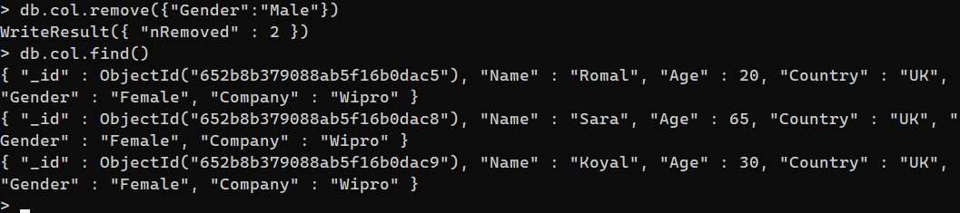

  - Find out a count of female users who stay in either India or USA.

  - Display the first name and age of all female employees.
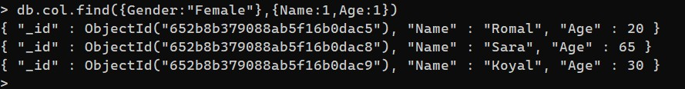

Practical 3 – Aggregate Functions

Insert collection in the database and display all the records.
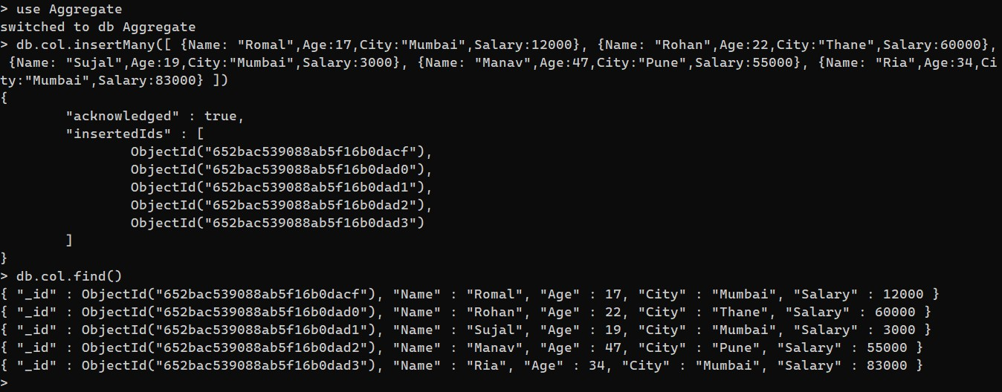

  - Group by function to get count.
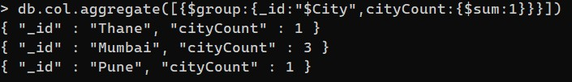

  - Sum function.
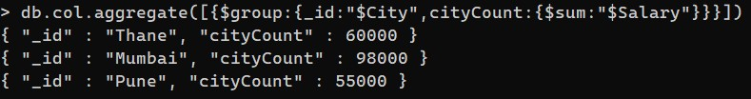

  - Avg function.
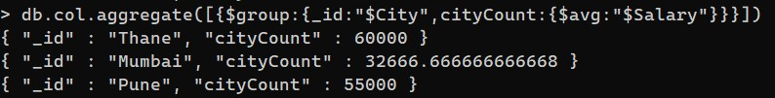
1. Min function 2. Max function.
  - First function
  - Last function
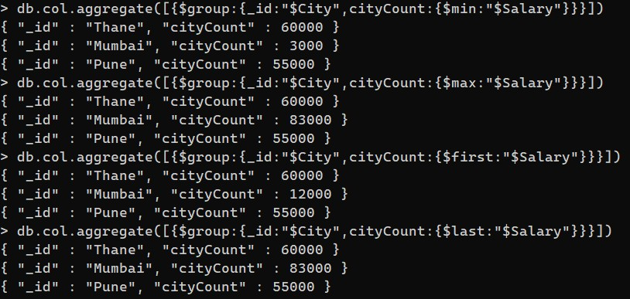

  - Push function
  - addToSet function
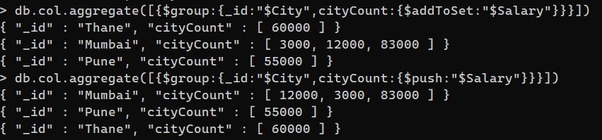

4. Java and MongoDB 1. Insert the document in MongoDB using Java.
import com.mongodb.client.MongoCollection; import com.mongodb.client.MongoDatabase; import com.mongodb.MongoClient; import org.bson.Document;
public class insert
{
public static void main(String[] args)
{
MongoClient mongo = new MongoClient("localhost",27017);
System.out.println("Connected to the database successfully.");
MongoDatabase database = mongo.getDatabase("TYITDB239720");
MongoCollection<Document> collection = database.getCollection("myCol");
System.out.println("Collection myCol selected successfully");
Document document = new Document(); document.append("id",1); document.append("Name","Romal"); document.append("RollNo",239720); document.append("Age",20); document.append("College","MCC"); collection.insertOne(document);
System.out.println("Document inserted successfully");
} }
Output:
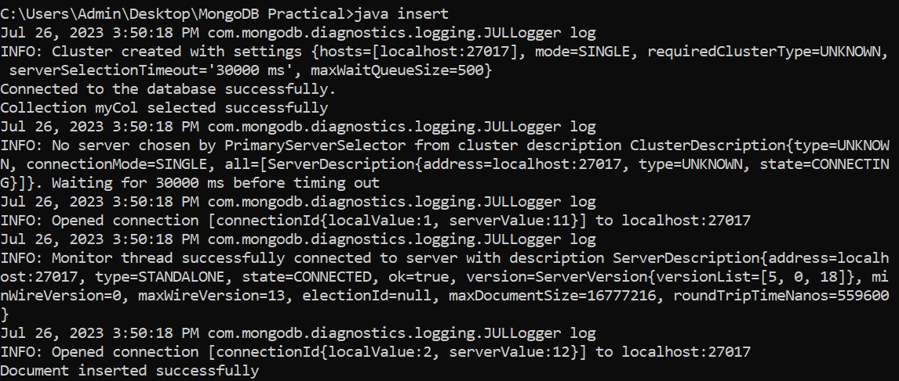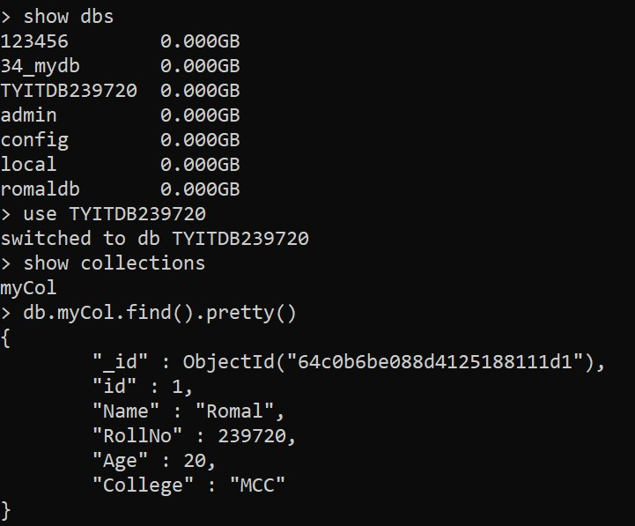

1. Update the document in MongoDB using Java.
import com.mongodb.DB; import com.mongodb.DBCollection; import com.mongodb.BasicDBObject; import com.mongodb.MongoClient; import com.mongodb.WriteResult; import java.net.UnknownHostException;
public class update
{
public static void main(String[] args)
{
MongoClient mongo = new MongoClient("localhost",27017);
System.out.println("Connected to the database successfully.");
DB db = mongo.getDB("TYITDB239720");
DBCollection col = db.getCollection("myCol");
BasicDBObject query = new BasicDBObject("id",1); BasicDBObject update = new BasicDBObject(); update.put("$set",new BasicDBObject("Age",27)); WriteResult result = col.update(query,update); mongo.close();
}
}

Output:
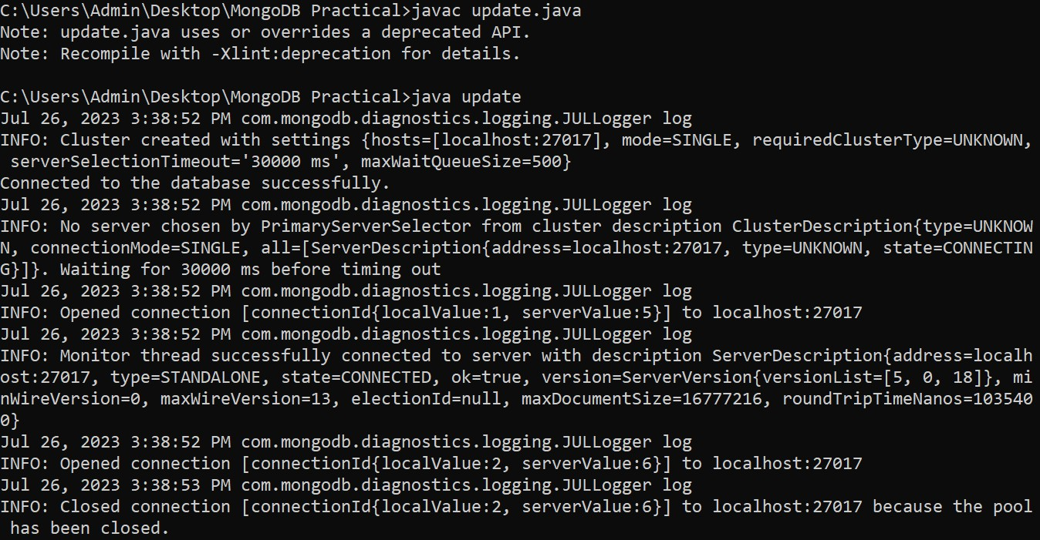
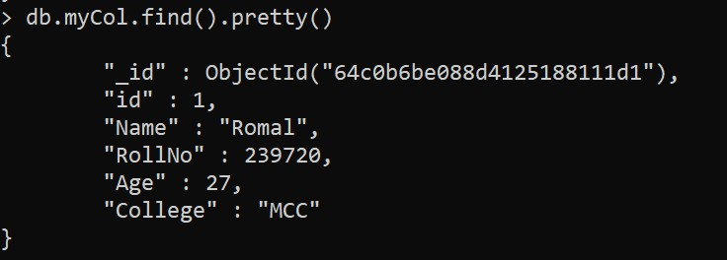

1. Retrieve the document in MongoDB using Java
import com.mongodb.client.MongoCollection; import com.mongodb.client.MongoDatabase; import com.mongodb.MongoClient; import com.mongodb.MongoCredential; import org.bson.Document; import java.util.Iterator; import com.mongodb.client.FindIterable;

public class retrieve
{
public static void main(String[] args)
{
MongoClient mongo = new MongoClient("localhost",27017);
System.out.println("Connected to the database successfully.");
MongoDatabase database = mongo.getDatabase("TYITDB239720");
MongoCollection<Document> collection = database.getCollection("myCol");
System.out.println("Collection myCol selected successfully"); FindIterable<Document> iterDoc = collection.find(); int i = 1;
Iterator it = iterDoc.iterator();
while(it.hasNext())
{
System.out.println(it.next());
i++;
}
}
}
Output:
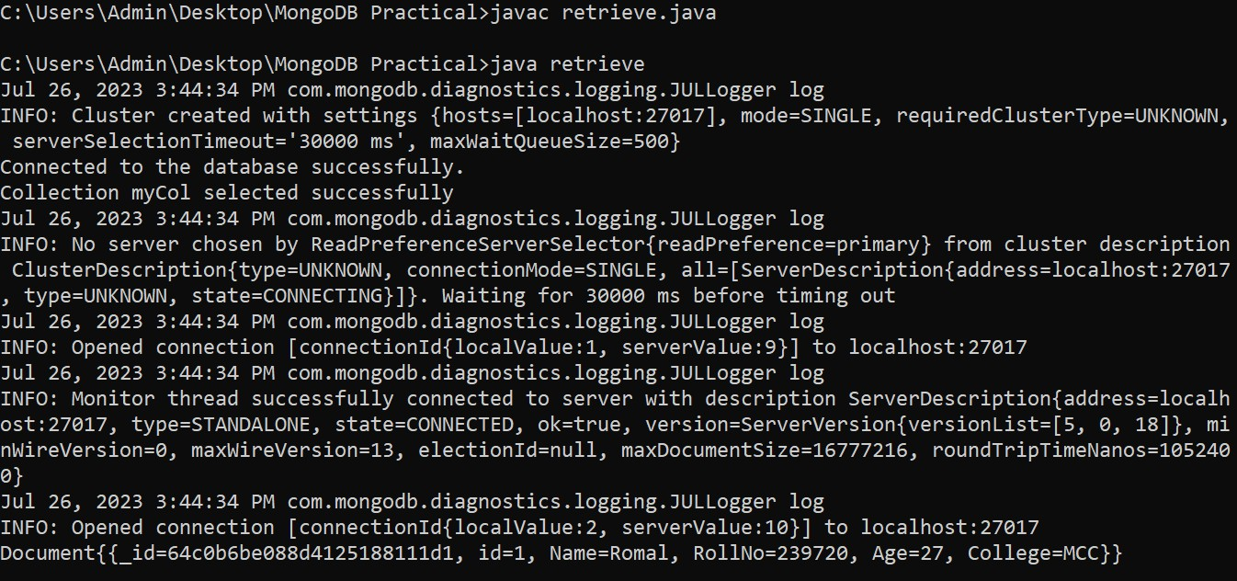

1. Delete the document in MongoDB using Java.
import com.mongodb.client.MongoCollection; import com.mongodb.client.MongoDatabase; import com.mongodb.MongoClient; import com.mongodb.MongoCredential; import org.bson.Document;
import com.mongodb.client.model.Filters; public class delete
{
public static void main(String[] args)
{
MongoClient mongo = new MongoClient("localhost",27017);
System.out.println("Connected to the database successfully.");
MongoDatabase database = mongo.getDatabase("TYITDB239720");
MongoCollection<Document> collection = database.getCollection("myCol");
System.out.println("Collection myCol selected successfully"); collection.deleteOne(Filters.eq("id",1));
System.out.println("Document deleted successfully");
}
}

Output:
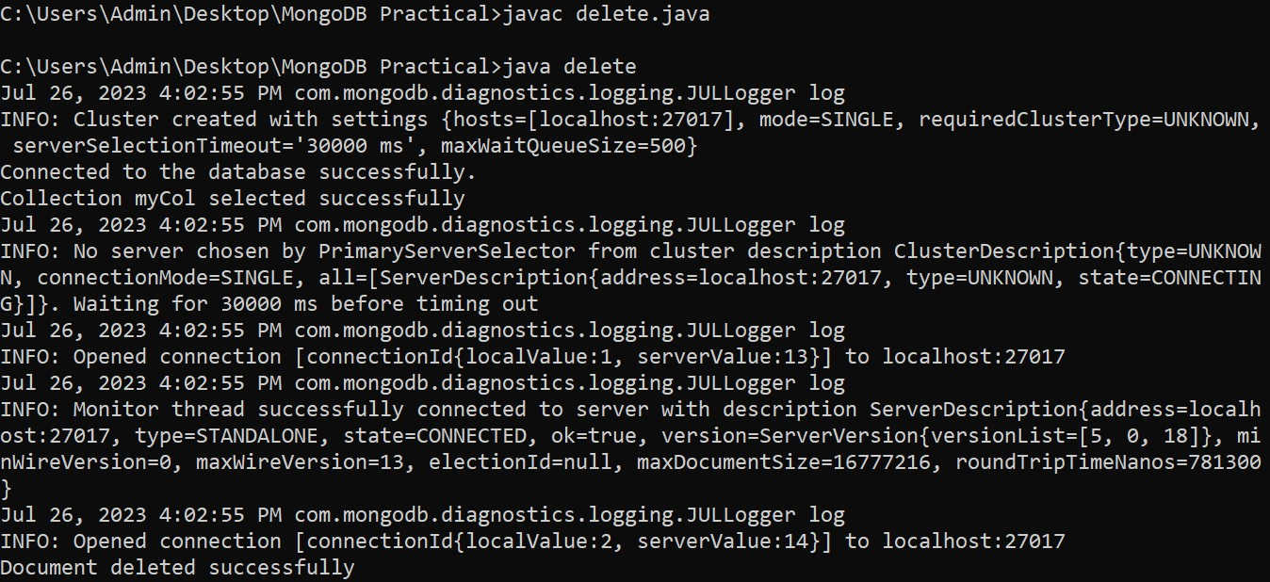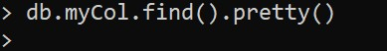

5.PHP
php_mongo.dll ---> copy this file and paste it in xampp--> php--> ext
Edit the configuration --> xampp --> php ---> php(Type:
Configuration setting)
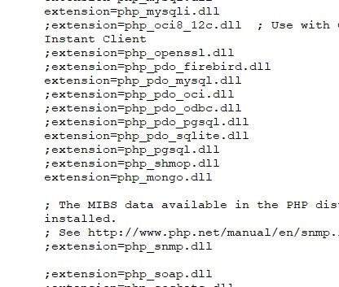

Save Files at the location:
C:\xampp\htdocs\

Execute:
Open xampp
Apache → Start (Make it active) and Admin(Make it active)
Browser will open
Remove dashboard and instead give the name of the file (eg: insert.php)
Output is printed.

insert.php
<?php
$m = new MongoClient();
echo "Connection to database successfully";
$db = $m -> MYDB239720; echo "\nDatabase selected successfully";
$col = $db -> MyCol;
echo "\nCollection selected successfully";
$doc = array(
"name" => "Romal",
"age" => 20,
"dept" => "TYIT",
"rollno" => 239720
);
$col -> insert($doc);
echo "\nDocument inserted successfully";
?>

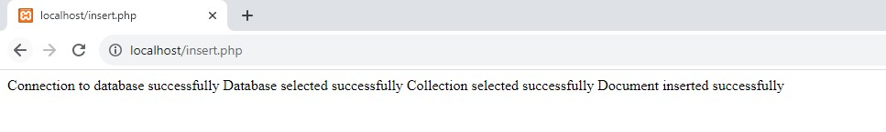
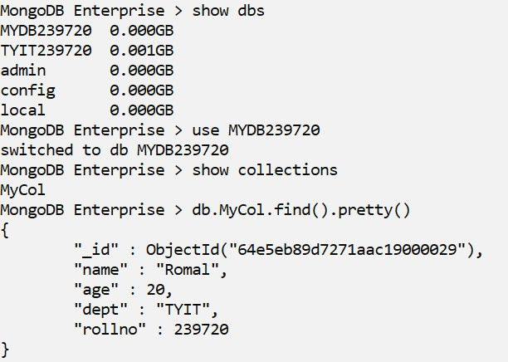

- update.php
<?php
$m = new MongoClient();
echo "Connection to database successfully";
$db = $m -> MYDB239720;
echo "\nDatabase selected successfully";
$col = $db -> MyCol;
echo "\nCollection selected successfully";
$col -> update(array( "name" => "Romal"),array('$set'=>array("age" => 19))); echo "\nDocument updated successfully";
?>
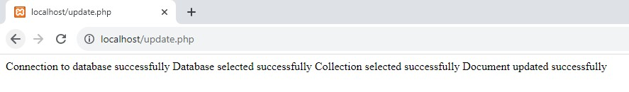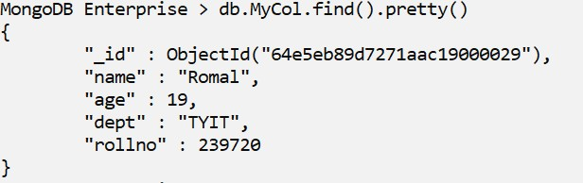

- retrieve.php
<?php
$m = new MongoClient();
echo "Connection to database successfully";
$db = $m -> MYDB239720; echo "\nDatabase selected successfully";
$col = $db -> MyCol;
echo "\nCollection selected successfully";
$cursor = $col -> find(); foreach($cursor as $doc)
{
echo"<br/>";
echo $doc["name"]."<br/>"; echo $doc["age"]."<br/>"; echo $doc["dept"]."<br/>"; echo $doc["rollno"]."<br/>";
}
?>
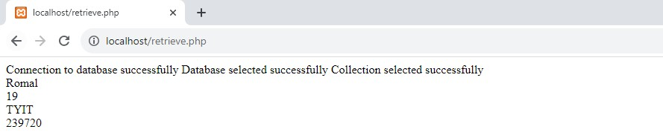

4. delete.php
<?php
$m = new MongoClient();
echo "Connection to database successfully";
$db = $m -> MYDB239720; echo "\nDatabase selected successfully";
$col = $db -> MyCol;
echo "\nCollection selected successfully"; $col -> remove(array( "name" => "Romal")); echo "\nDocument deleted successfully";
?>

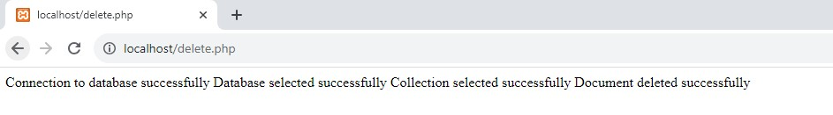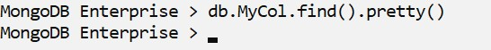

6.Python
1. insert

from pymongo import MongoClient client = MongoClient('localhost',27017) db = client.TYITDB239720 def insert(): try:
name1 = input("Enter the Name:") age1 = input("Enter the Age:") dept1 = input("Enter the Department:") pin1 = input("Enter the Pin No:") db.MyCol.insert_one({
"name":name1,
"age":age1,
"dept":dept1,
"pin":pin1
})
print("Inserted data successfully") except Exception: print(str(e))

insert()

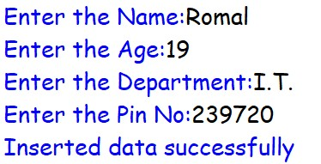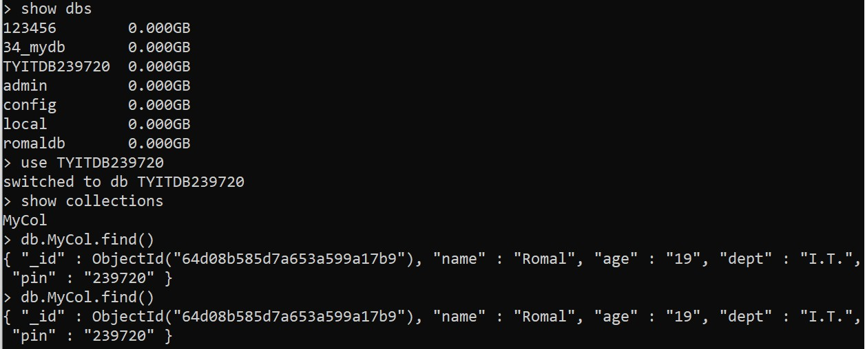

2. update()

from pymongo import MongoClient client = MongoClient('localhost',27017)
db = client.TYITDB239720 def update(): try:
name1 = input("Enter the Name:") age1 = input("Enter the Age to update:")
db.MyCol.update_one({"name":name1},{"$set":{"age":age1}}) print("\nRecords updated successfully\n") except Exception:
print(str(e))

update()

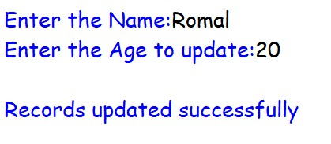

3. Retrieve

from pymongo import MongoClient client = MongoClient('localhost',27017)
db = client.TYITDB239720 def read(): try:
Col = db.MyCol.find()
print("\nAll data from database TYITDB239720:") for MyCol in Col: print(MyCol) except Exception:
print(str(e))

read()

4. delete

from pymongo import MongoClient client = MongoClient('localhost',27017) db = client.TYITDB239720
def delete(): try:
name1 = input("Enter the name:") db.MyCol.delete_one({"name":name1}) print("\nData deleted successfully") except Exception:
print(str(e))

delete()

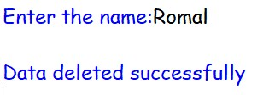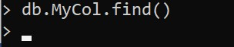

Practical 7
1. Write a jQuery to check the contents of the elements on the button click.

<!DOCTYPE html>
<head>
<title>Basic jQuery</title>
<script src="jquery-3.6.1.min.js"></script>
<script>
})

$
(
document
).
ready
(
function

()

{

$
(
"#btn"
).
click
(
function
()
{

document.write
(
"Hello Romal"
)

}
)

<
/script
>

<
/head
>

<
body
>

<p>Romal: 239720</p>
<button id="btn">Click Me</button>
</body>

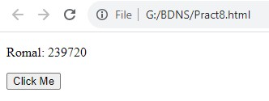

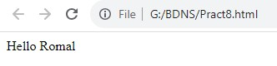

2. Write a jQuery to select elements by class name, id and | element
names.

<!DOCTYPE html>
<head>
<title>Basic jQuery</title>
<script src="jquery-3.6.1.min.js"></script>
<script>
$(document).ready(function() {
$(".class1").css("background","lightblue");
$("#id1").css("background","pink");
$("h2").css("background", "lightgreen");
})
</script>
</head>
<body>
<p class="class1">Romal: 239720</p>
<p id="id1">Romal Shah</p>
<h2>Welcome Romal</h2>
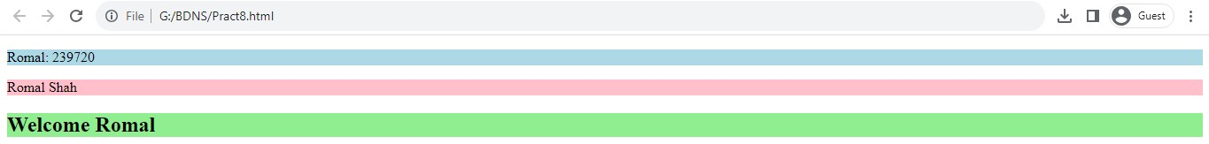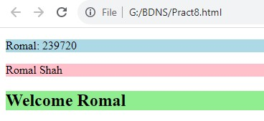
<
/body
>

3. Write jQuery to show the use of click(), hover(), on(), trigger(),off() events.

<!DOCTYPE html>
<head>
<title>Basic jQuery</title>
<script src="jquery-3.6.1.min.js"></script>
<script>
});

$
(
document
).
ready
(
function

()

{

$
(
"#b1"
).
hover
(
function
{
()

document.write
(
"Hello Romal
"
)

)
}

$
(
"p"
).
on
(
"click"
,

function
()

{

$
(
this
).
css
(
"background"
,

"yellow"
;
)

})
;

$
(
"#b2"
).
click
(
function
{
()

$
(
"p"
).
off
(
"click"
)
;

})
;

$
(
"#b3"
).
on
(
function
{
()

$
(
"#t1"
).
hide
()
;

})
;

$
(
"input"
).
select
(
function
()
{

$
(
"input"
).
after
(
Marked!"
"Text
)

})
;

$
(
"#b4"
).
click
(
function
()
{

$
(
"input"
).
trigger
(
"select"
)
;

<
/head
>

})
</script>
<body>
<button id="b1">Hover</button><br>
<p>Welcome to the Mulund College</p><br>
<p>Romal: 239720</p><br>
<button id="b2">Off</button><br>
<p id="t1">Hello Romal</p><br>
<button id="b3">On</button><br>
<input type="text" value="Romal 239720"><br>
<button id="b4">Trigger</button><br>
</body>
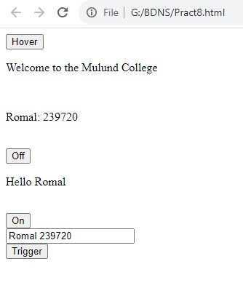

Hover:

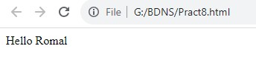

Click, on, off
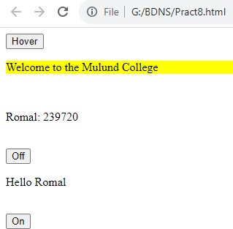

Trigger:

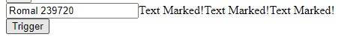

1. Write a jQuery to create animated show hide effect.

<!DOCTYPE html>
<head>
<title>Basic jQuery</title>
<script src="jquery-3.6.1.min.js"></script> <script>

$
(
document
).
ready
(
function
()
{

$
(
"#b1"
).
click
(
function
()
{

$
(
"p"
).
hide
()
;

})
;

$
(
"#b2"
).
click
(
function
(){

$
(
"p"
).
show
;
()

}
)

}
)

<
/script
>

<
/head
>
<body>
<p>Romal Shah:239720</p>
<button id="b1">Hide</button>
<button id="b2">Show</button>
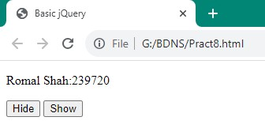
<
/body
>

.

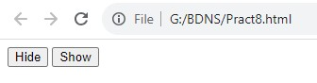

1. Write a jQuery to create a simple toggle effect.

<!DOCTYPE html>
<head>
<title>Basic jQuery</title>
<script src="jquery-3.6.1.min.js"></script> <script>

$
(
document
).
ready
(
function
(){

$
(
"button"
).
click
(
function
()
{

$
(
"p"
).
toggle
()
;

})
;

}
)

<
/script
>

<
/head
>

<
body
>

<
p
>
Romal Shah:239720
<
/p
>
<button>Toggle</button>
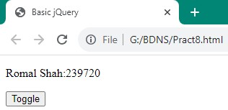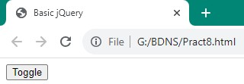
<
/body
>

1. Write a jQuery to create fade-in and fade-out effect.

<!DOCTYPE html>
<head>
<title>Basic jQuery</title>
<script src="jquery-3.6.1.min.js"></script>
<script>

$
(
document
).
ready
(
function
{
()

$
(
".c1"
).
click
(
function
()
{

$
(
"p"
).
fadeOut
(
5000
)
;

})
;

$
(
".c2"
).
click
(
function
()
{

$
(
"p"
).
fadeIn
(
5000
;
)

}
)

}
)

<
/script
>

<
/head
>

<
body
>

<p>Romal Shah:239720</p>
<button class="c1">Fade Out</button>
<button class="c2">Fade In</button>
</body>
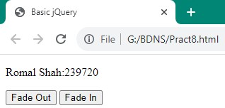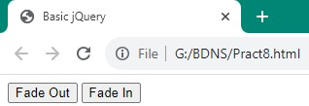

1. Write a jQuery to create fade toggle effect.

<!DOCTYPE html>
<head>
<title>Basic jQuery</title>
<script src="jquery-3.6.1.min.js"></script>
<script>
})

$
(
document
).
ready
(
function
(){

$
(
"button"
).
click
(
function
(){

$
(
"p"
).
fadeToggle
(
5000
)
;

})
;

<
/script
>

<
/head
>

<
body
>

<p>Romal Shah:239720</p>
<button>Fade Toggles</button>
</body>
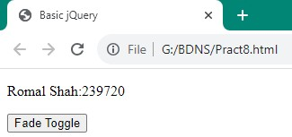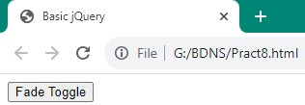

1. Write a jQuery to create slide-up and slide-down effect.

<!DOCTYPE html>
<head>
<title>Basic jQuery</title>
<script src="jquery-3.6.1.min.js"></script>
<script>

$
(
document
).
ready
(
function
{
()

$
(
"#b1"
).
click
(
function
()
{

$
(
"p"
).
slideUp
(
3000
)
;

})
;

$
(
"#b2"
).
click
(
function
(){

$
(
"p"
).
slideDown
(
3000
)
;

)
}

}
)

<
/script
>

<
/head
>

<
body
>

<p>Romal Shah:239720</p>
<button id="b1">Slide Up</button>
<button id="b2">Slide Down</button> </body>
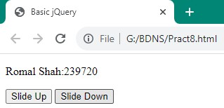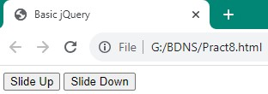

1. Write a jQuery to create slide toggle effect.

<!DOCTYPE html>
<head>
<title>Basic jQuery</title>
<script src="jquery-3.6.1.min.js"></script>
<script>

$
(
document
).
ready
(
function
(){

$
(
"button"
).
click
(
function
(){

$
(
"p"
).
slideToggle
(
5000
)
;

}
)

}
)

>
<
/script

<
/head
>

<
body
>

<
p
>
Romal Shah:239720
<
/p
>

<button>Slide Toggle</button>s
</body>
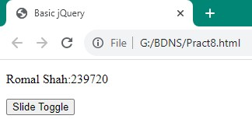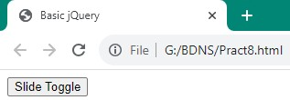

1. Write a jQuery to create Mouse Event.

<html>
<!
DOCTYPE html
>

<head>
<title>Basic jQuery</title>
<script src="jquery-3.6.1.min.js"></script>
<script>

$
(
document
).
ready
(
function
()
{

$
(
"#p1"
).
mouseleave
(
function
(){

alert
(
"Bye! You now leave p1"
;
)

)
}

}
)

<
/script
>

<
/head
>

<
body
>

<
p

id
=
"p1"
>
This is a paragraph
<
/p
>

</body>
</html>

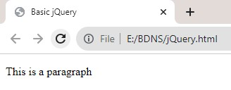
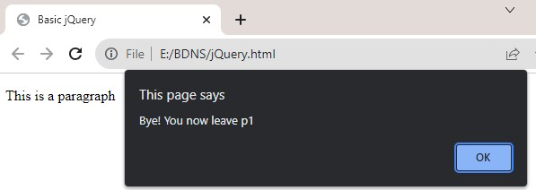

Practical 8
1. Write a jQuery to create animation effect.

<!
DOCTYPE html
>

<
head
>

<title>Basic jQuery</title>
<script src="jquery-3.3.1.min.js"></script>
<script>

$
(
document
).
ready
(
function
(){

$
(
"button"
).
click
(
function
{
()

$
(
"img"
).
animate
({
left
:
50
;
})

}
)

)
}

<
/script
>

<
style
>

img{position:relative;}

<
/style
>

<
/head
>

<
body
>

<p>Romal:239720</p>
<img src="Mountain.png" alt="Mountain Image"><br>
<br><button>Start Animation</button>
</body>
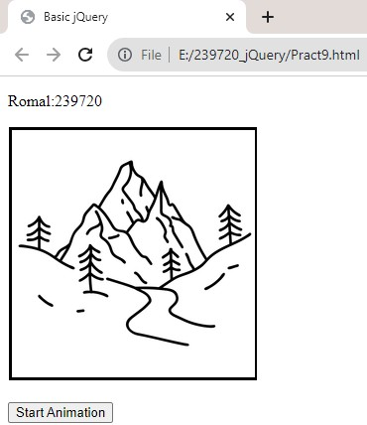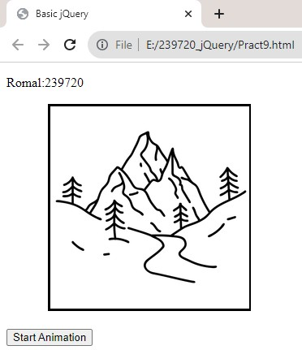

1. Write a jQuery to animate multiple css properties.

<html>
<head>
<script src="jquery-3.6.1.min.js"></script>
<
>
script

$
(
document
).
ready
(
function
(){

$
(
"#b1"
).
click
(
function
()
{

$
(
"#div1"
).
animate
({
width
:
"150px"
,
height
:
"150px"
,
opacity
:
"0.5"
,
l
ft
e
:
"150"
})
;

}
)

})

<
/script
>

<
style
>

#div1{width:100px;height:100px;background:yellow;position:rela
tive;}

<
/style
>

<
/head
>

<
body
>

<
p
>

Animation
<
/p
>

<div id="div1"></div>
<button id="b1">Click to Animate</button>
</body>
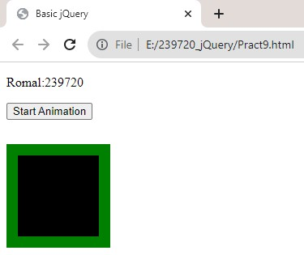
<
/html
>

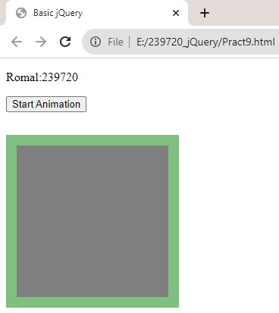

1. Write a jQuery to perform method of chaining.

<!
DOCTYPE html
>

<
head
>

<title>Basic jQuery</title>
<script src="jquery-3.3.1.min.js"></script>
<script>

$
(
document
).
ready
(
function
(){

$
(
"button"
).
click
(
function
()
{

$
(
"#p1"
).
css
(
"color"
,
"blue"
).
slideUp
(
2000
).
slideDown
(
2000
)

}
)

}
)

>
<
/script

<
/head
>

<
body
>

<
p

id
=
"p1"
>
Romal:239720
<
/p
>

<button>Click Me</button>
</body>
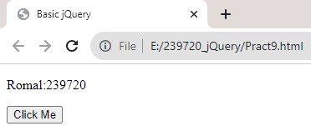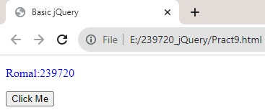

Practical 9

1. Write a jQuery effect method with a callback function.
<!
DOCTYPE html
>

<
head
>

<title>Basic jQuery</title>
<script src="jquery-3.3.1.min.js"></script>
<script>
})

$
(
document
).
ready
(
function
(){

$
(
"button"
).
click
(
function
()
{

$
(
"p"
).
hide
(
"slow"
,
function
(){

alert
(
"The paragraph is now hidden"
)

<
/head
>

<
body
>

<
p
>
Romal:239720
<
/p
>

})
})
</script>
<p>Welcome to MCC</p>
<button>Click!</button>
</body>
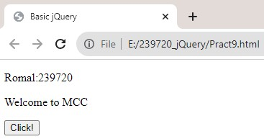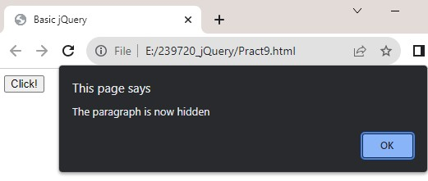

1. Write a jQuery to get and set text context of the elements.

<!DOCTYPE html>
<head>
<title>Basic jQuery</title>
<script src="jquery-3.6.1.min.js"></script>
<script>
$(document).ready(function(){ $("#b1").click(function(){
var str = $("p").text();
alert(str);
})
$("#b2").click(function(){
$("p").text("Hello World");
})
})
</script>
</head>
<body>
<p>Romal Shah:239720</p>
<p> MongoDB</p>
<button id="b1">Get</button> <button id="b2">Set</button>
</body>
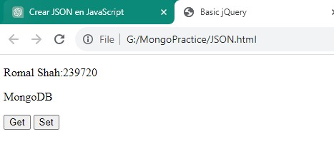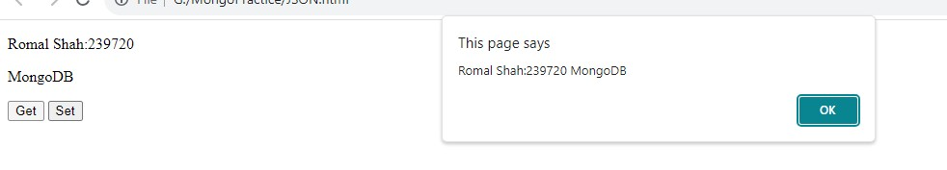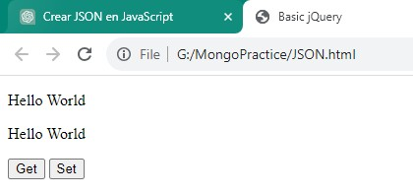

1. Write a jQuery to get and set HTML contents of the elements.

<!DOCTYPE html>
<head>
<title>Basic jQuery</title>
<script src="jquery-3.6.1.min.js"></script>
<script>

$
(
document
).
ready
(
function
{
()

$
(
"#b1"
).
click
(
function
()
{

var

str
=

$
(
"p"
).
html
()
;

alert
(
str
)
;

)
}

$
(
"#b2"
).
click
(
function
()
{

$
(
"p"
).
html
(
"<b>Hello World<b>"
)
;

}
)

}
)

<
/script
>

<
/head
>

<body>
<p><b>Romal Shah:</b><u>239720</u></p>
<p> MongoDB</p>
<button id="b1">Get</button> <button id="b2">Set</button>
</body>

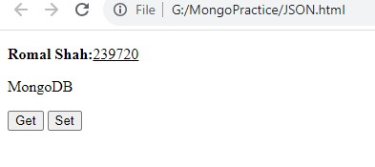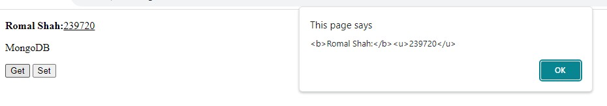

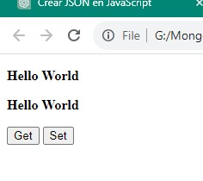

10. JSON Creating JSON

<html>
<head>
<title>Creating JSON</title>
</head>
>
body
<

script
<

type
=
"text/javascript"
>

var

data
{
=

"name"
:
"Romal"
,

"age"
:
20
,

"dept"
:
"
"IT

}

doc
ument.writeln
(
JSON.stringify
(
data
)+
"</br>"
)
;

doc
ument.writeln
(
JSON.stringify
(
data
,[
"name"
,
"age"
,
"dept"
])
+
r/>"
"<b
)
;

doc
ument.writeln
(
JSON.stringify
(
data
,[
"name"
,
"age"
,
"dept"
,
]
5
;
))

<
/script
>

<
/bo

dy>

</html>
Output:
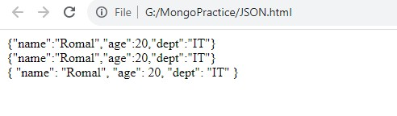

Parsing JSON
<html>
<body>
<script type="text/javascript">
var data = '{"name":"Romal","age":20,"dept":"IT"}'; var jsonObj = JSON.parse(data, function(name, value) { return value;
});
document.writeln
(
jsonObj.name
;
)

for

(
key
in

jsonObj
)

{

document.writeln
(
"<
br/>"

+

key
+

" : "

+

jsonObj
[
key
])
;

}

var

jsonObj
=

.parse
JSON
(
data
,

function
(
name
,

value
)

{

if

(
name
==

"sem"
)

{

return

undefined
;

}

else

{

return

value
;

}

;
})

for

(
key
in

jsonObj
)

{

document.writeln
(
"<br/>"

+

key
+

" : "

+

jsonObj
[
key
])
;

}

<
/script
>

<
/body
>

<
/html
>

Output:
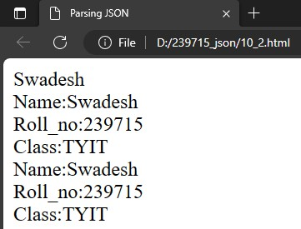

3.
<html>
<body>
<script type="text/javascript">
var data = '{"name":"Romal","age":20,"dept":"IT"}';
var obj = JSON.parse(data); for(var key in obj)
{
document.writeln(“<br/>+”key+":"+obj[key]);
}
</script>
</body>
</html> Output:

